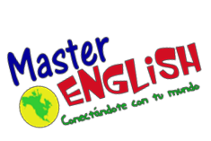

Homework Unit 6

1. Write the vocabulary 3 times in your notebook.
2. Answer Practice Book, pages 34-35.
3. Answer Twist and Shout Homework Book, pages 19-21.
4. Visit the following websites and practice.

http://genkienglish.net/going.htm
https://www.eslfast.com/kidsenglish/ke/ke001.htm
http://enjoyenglish.free.fr/english/college/goingto/index.html
https://conteni2.educarex.es/mats/17320/contenido/

At the museum |  | Words | Yes / no questions.
aquarium dinosaur  cafeteria elevator gift shop | museum restrooms  report tomorrow tour guide | give free  notes  School Principal | We’re going to see the dinosaurs. We aren’t going to buy gifts in the  gift shop.  They’re going to be noisy. They’re not going to be quiet.

