Homework Unit 3
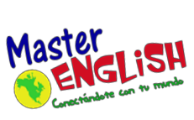

1. Write the vocabulary 3 times in your notebook.
2. Answer Practice Book, pages 29-30.
3. Answer Twist and Shout Homework Book, pages 10-12.
4. Visit the following websites and practice.

https://www.eslgamesplus.com/nature-vocabulary-memory-game-for-esl-practice/
https://www.gamestolearnenglish.com/falling-english/
https://www.englisch-hilfen.de/en/exercises/adjectives_adverbs/adjectives_comparison_sentences.htm
https://agendaweb.org/exercises/grammar/comparison/comparison-multiple-1

Adjectives |  | Animals/Parts of  animals | Sentences
amazing  colorful  dangerous endangered expensive | frightening  intelligent  popular powerful unusual | koala  kangaroo  platypus beak | Parrots are more colorful than chickens.  Caterpillars aren’t as beautiful as  butterflies.

