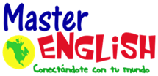
Homework Unit 9
Vocabulary |  | Shapes
- tree  - flower  - car  - bicycle  - bus  - plane | - dress  - blouse  - skirt  - shirt  - pants  - shoes | - circle  - square  - triangle  - rectangle  - diamond  - oval
- Write the vocabulary 3 times in your notebook.
- Answer Practice Book, pages 51-52.
- Answer Twist and Shout Workbook, pages 28-30.

https://www.youtube.com/watch?v=0QrcDQSxfCY

